Prepared by: Audrey Waggener
AW Networking solutions 1212 W Brooke St.
Network Proposal
Prepared for the Davis Brothers
Executive Summary:
- Overview:
  - This is going to be a simple home installation designed to support the clients’ needs for a secured network suitable for high-speed gaming as well as work.
- Current Situation:
  - The client’s current network is insecure and cannot support all of the clients’ needs for the network. While it takes care of their minimum network needs, their connection is disrupted due to neighbors accessing their network unauthorized. It is also incapable of supporting the clients’ desire to hold wired LAN parties with their friends. The client’s hardware is minimal although they do have a switch which gives them extra support for some of their gaming needs but is still insufficient.
- Objective:
  - The proposed network will allow the clients to have a secure network split into guest and public ensuring that the clients have access to the best speeds on their network. The network will allow the clients to have a wired connection throughout the home giving them a better competitive edge when gaming as well as a better connection for working from home.
- Proposed System:
  - To achieve these objectives the proposed system will use a managed switch for all the ports on the network. The system will use Cat6a cabling allowing for optimal speeds throughout the home. All networks will be secured preventing any unauthorized users from using the network.
- Summary of Recommendations:
  - We propose a network with a guest and private network both wired and wireless, each network password access and encrypted. Everything will be connected by Cat 6a cabling to ensure fast speeds. Internet will be provided by Vyve Broadband allowing the client to get 960Mbps download which is more than sufficient for all their needs. The network will use a managed switch with plenty of ports dedicated to both the guest and private networks.
Logical Design:
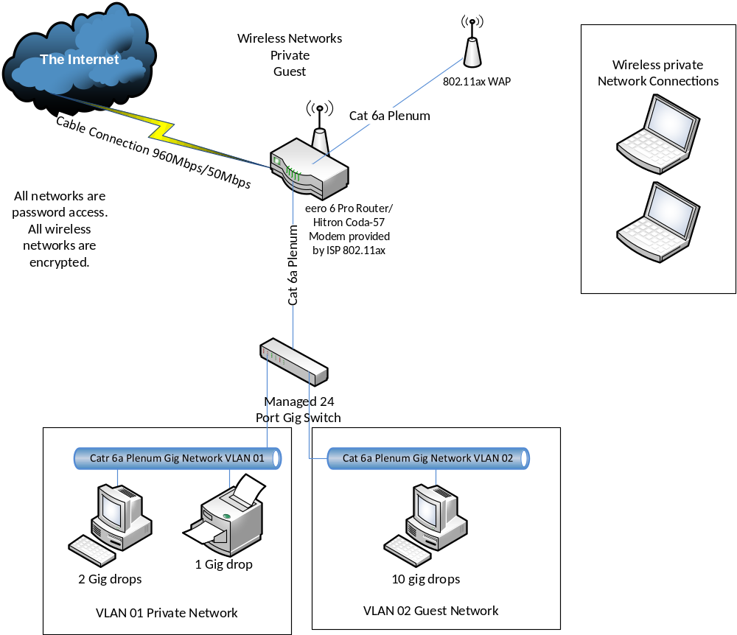
- Logical Design:
  - Using Vyve Broadband as the Internet Service Provider speeds up to 960Mbps download and 50Mbps upload are possible, providing ample speeds for all client needs. The ISP provides a router using 802.11ax, which ensures that the network will not be impacted by a possible “Faraday Cage” effect. There is a managed 24 port switch allowing for enough ports for all the clients’ needs as well as a second WAP as per request. There is a guest and private network for both the wireless network and the wired VLAN. Every network is accessed by password to ensure that only those with the password can use the network and all wireless networks are encrypted. Guest users have permission to use the network while the Davis’s on the private network can control network settings and control who has access to the network as well as guest permissions.
- Networks Defined:
  - The guest wireless network can be used by any guests for their personal devices such as phones and laptops while the private wireless network is for any of the clients’ devices not using the wired connection. The private wired network is for the clients’ desktops and printer in the office as well as any other devices they may wish to use a wired connection for. The guest wired network is allocated for the clients wired LAN parties.
Physical Design:
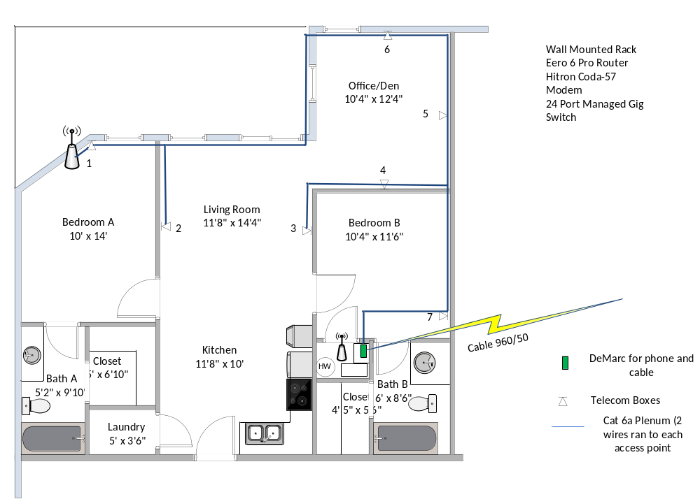
- Physical Layout:
  - Ports 3 – 9, 13, 15 and 16 are set to VLAN02. Ports 1, 2, 14, and 10-12 are set to VLAN01. This ensures there are designated ports for the client’s printer and workstations in the office as well as 2 ports for any devices the client has in Bedroom A and one port for Bedroom B while leaving enough ports available on the guest network for the client to be able to have wired LAN parties with 10 or more simultaneous players.
- Hardware Resources:
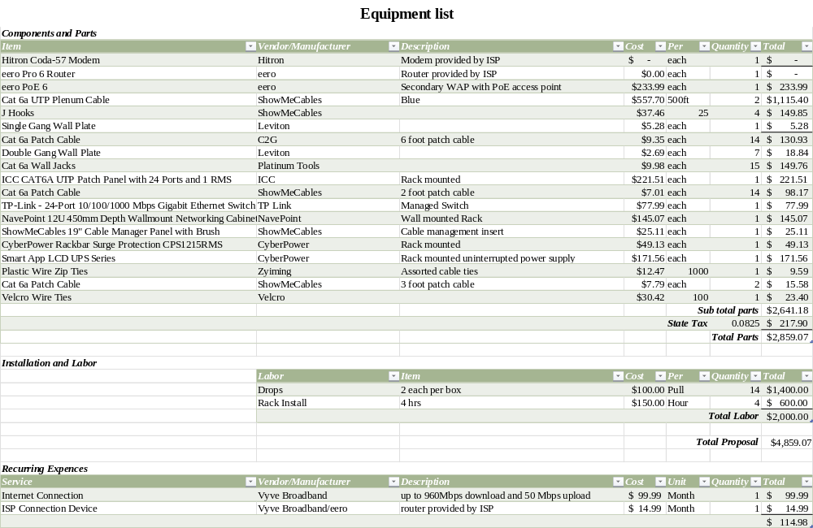
System Installation, Implementation, and Management:
- Description
  - The timeline for this project begins on June 3rd with the preliminary walkthrough where we will go through the apartment and make note of anything not mentioned in the RFP that could be an issue during installation. On the same day we will receive the hardware cost from the clients allowing for the initial parts to be ordered the next day. These will include all cabling, wall plates and jacks, as well as J-Hooks to manage the cables, and the rack. We will not order the switch, UPS, or power bar until the next day to leave less room for these more expensive parts to be lost or stolen while the installation of the cabling is happening. Ideally as shown on the installation chart all the initial parts ordered will be delivered by Monday the following week and wire installation will begin that Tuesday on June 13. Three days are scheduled for wire installation, ensuring there is plenty of time allocated in case of any unexpected issues running the wire or mounting the wall jacks. Installation of the rack will begin on the last day of wire installation and there are two days dedicated to rack installation. The following week we will start with the walk through to go over and show all the connections and the rack to the client and create a list of anything the client would like to alter or repair. The next day is scheduled to address any of these alterations or repairs brought up by the client. If they have none then the final walkthrough can be moved up a day but it is scheduled for the day after the punch list is addressed. Everything is scheduled to be complete by the 23 of June.
- Installation Schedule:
